✅ **Classic Azure Data Factory scenario** called **hybrid data movement** (on-premises to cloud). Data Migration. Project-3

This is the architecture of the project: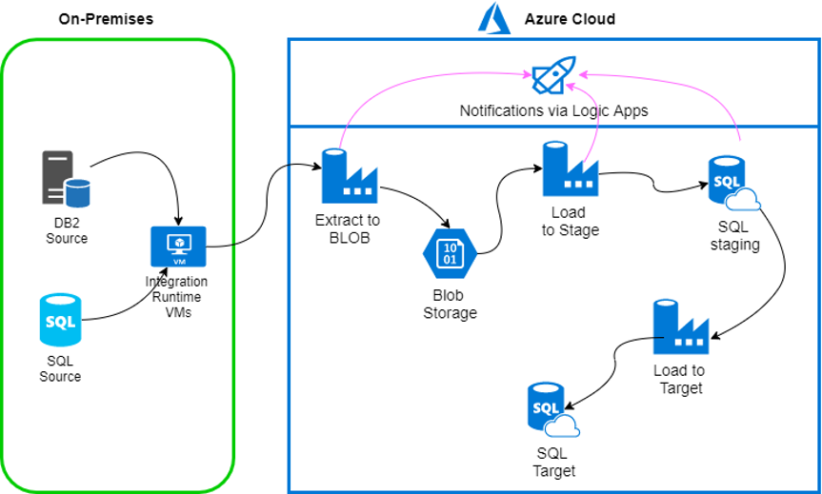

**Pipeline**

* **Steps to move data from on-premises to Azure using ADF:**

1️⃣ **Create a pipeline**

Define the overall workflow to orchestrate the data movement.

2️⃣ **Add a Copy Activity**

This will perform the actual data transfer **from the on-premises source to the cloud target**.

3️⃣ **Create datasets**

One dataset for the **source location** (on-prem SQL Server or file share).

One dataset for the **target location** (Azure SQL Database or Azure Data Lake).

4️⃣ **Configure Linked Services and Integration Runtime**

**Create linked services for:**

Source connection (using **Self-hosted Integration Runtime** for on-prem access).

Target connection (using **AutoResolveIntegrationRuntime** or default Azure IR).

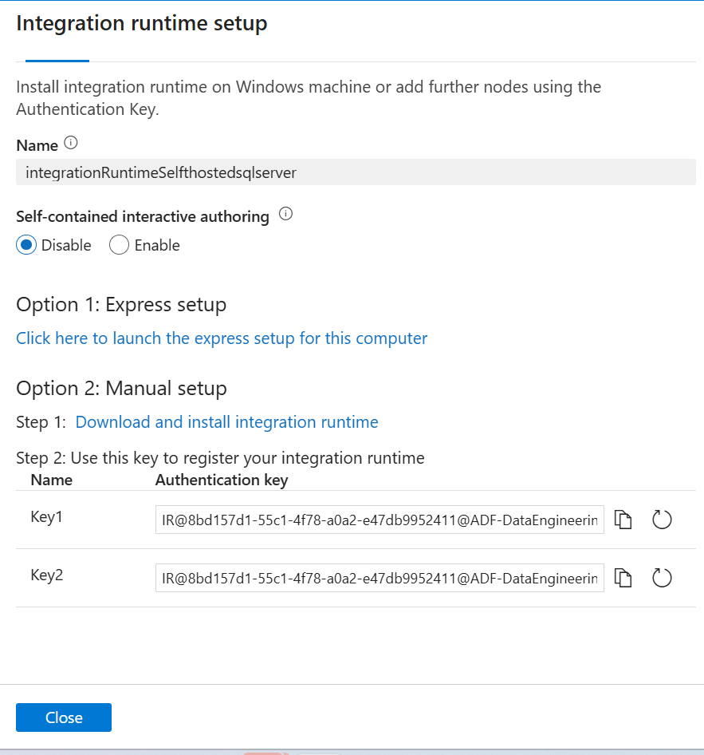

🎯 **What you are seeing in the screenshot:**  
This is the **manual setup screen** for configuring **Self-hosted Integration Runtime (IR)** in Azure Data Factory.

✅ **What this means in simple words:**  
👉 *You are preparing the secure connector that will let ADF talk to your on-premises SQL Server or file*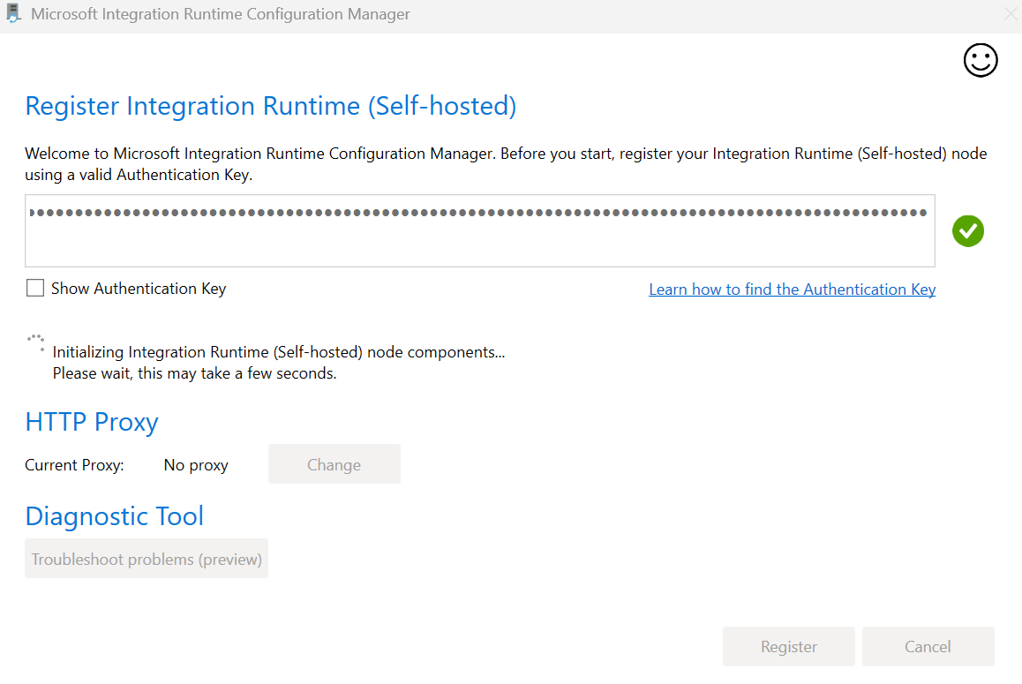

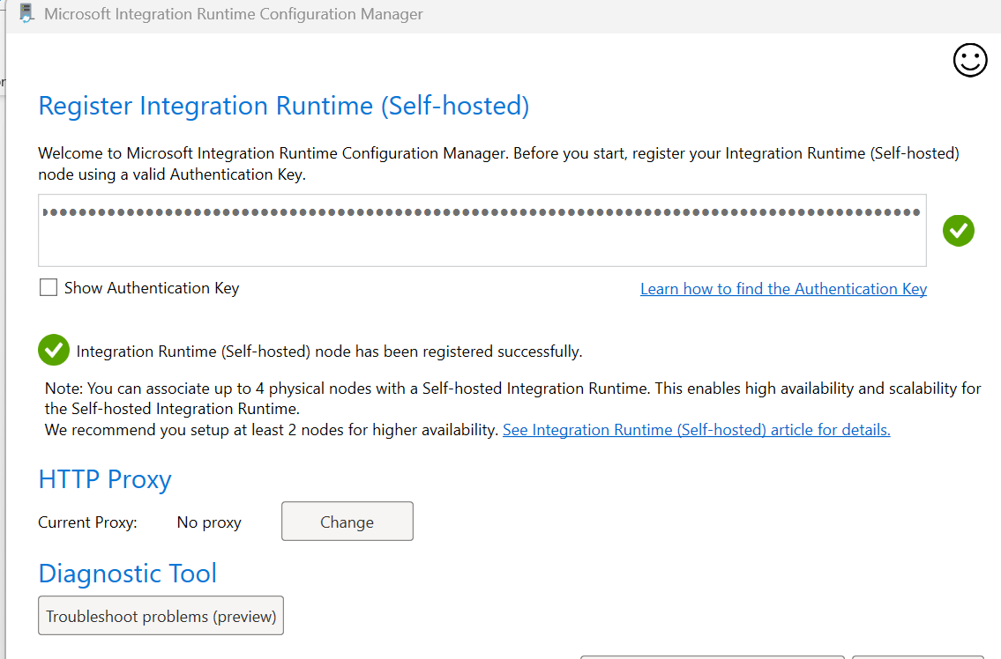

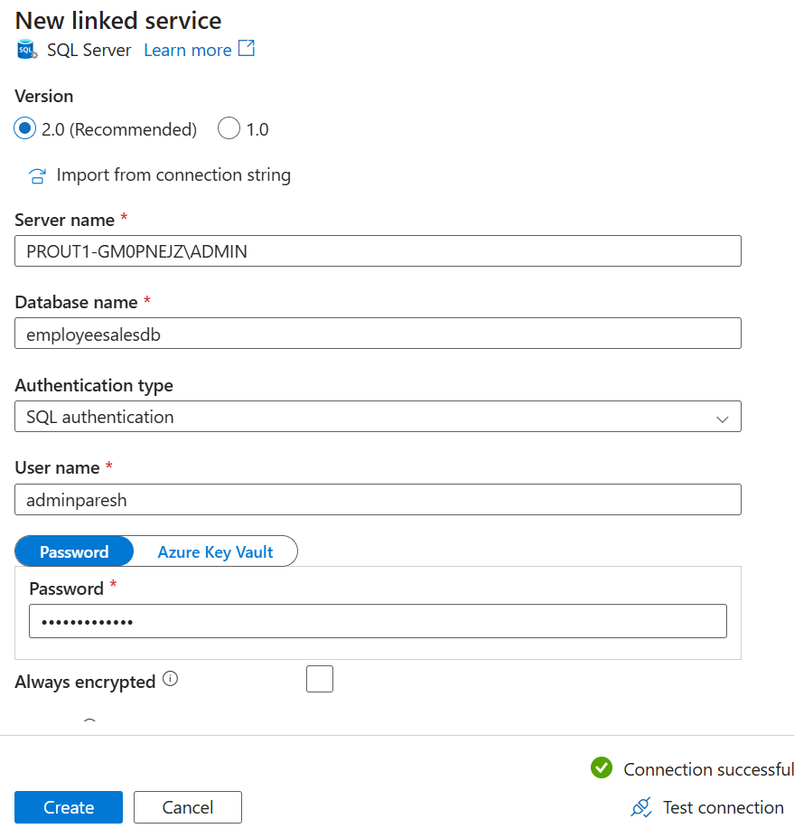

**Now the Integration Runtime (Self-hosted node has been registered and Link service ready successfully.**

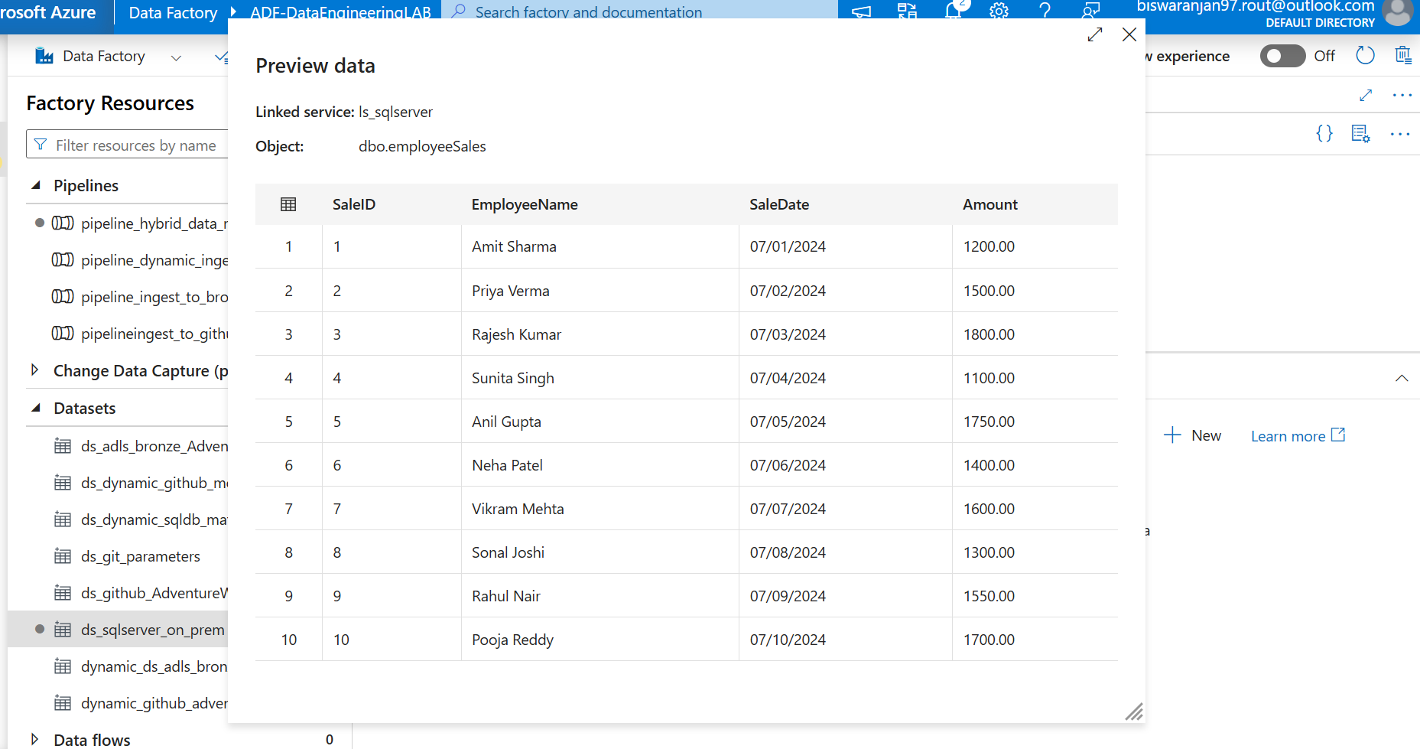

**Configured Source and Sink both in the copy activity”:**

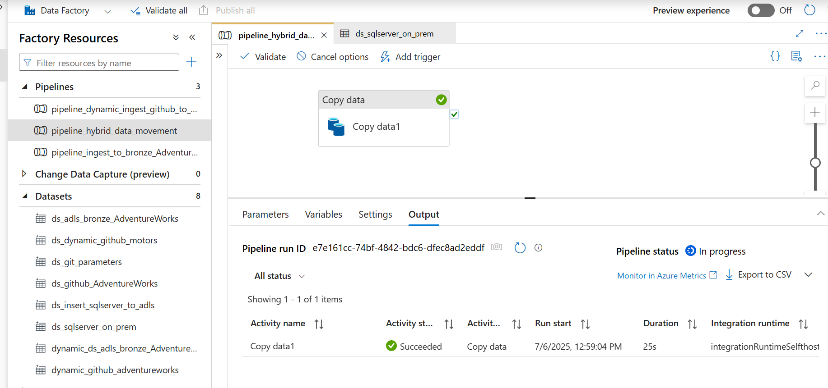

**Final Validation Steps After Pipeline Success**

**✅ Validation 1: Row Count Verification  
Objective: Ensure the number of rows in the source and target tables match.  
Example Line:**

***We validated that the total row count in the destination matches the source after pipeline execution.***

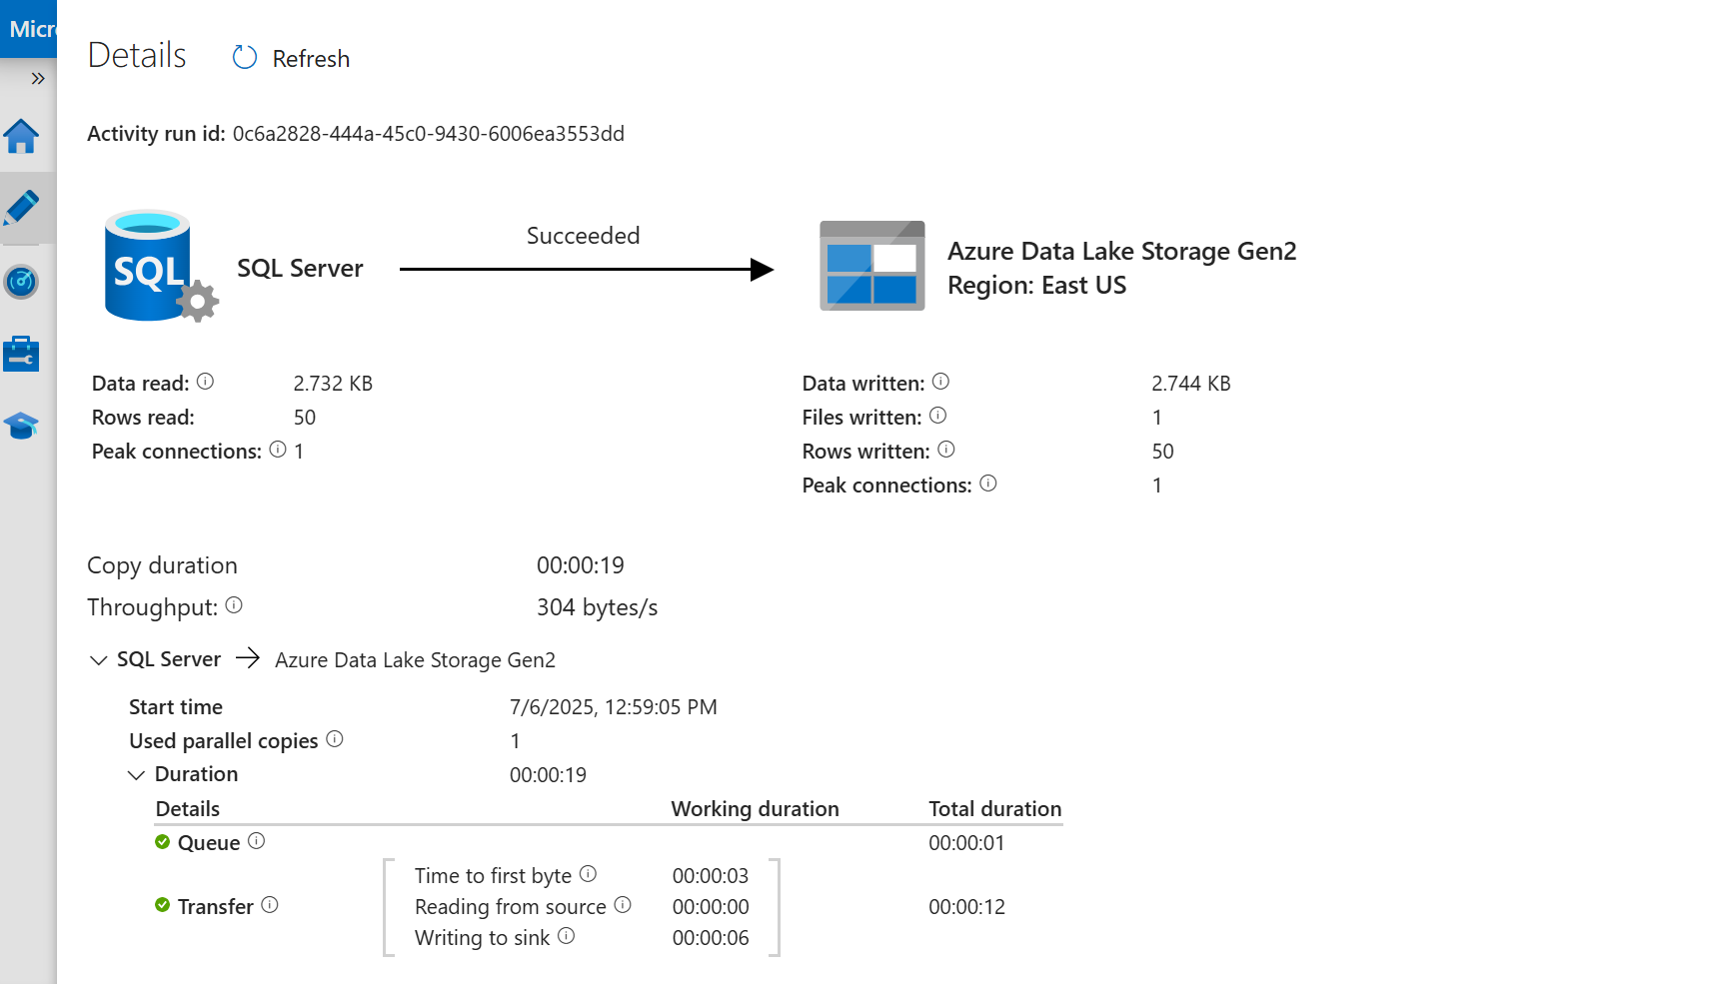

**✅ Validation 3: Data Accuracy  
Objective: Spot-check sample rows from source vs. target to confirm accurate data movement.  
Example Line *Randomly sampled records show the data transferred accurately without transformation loss.***

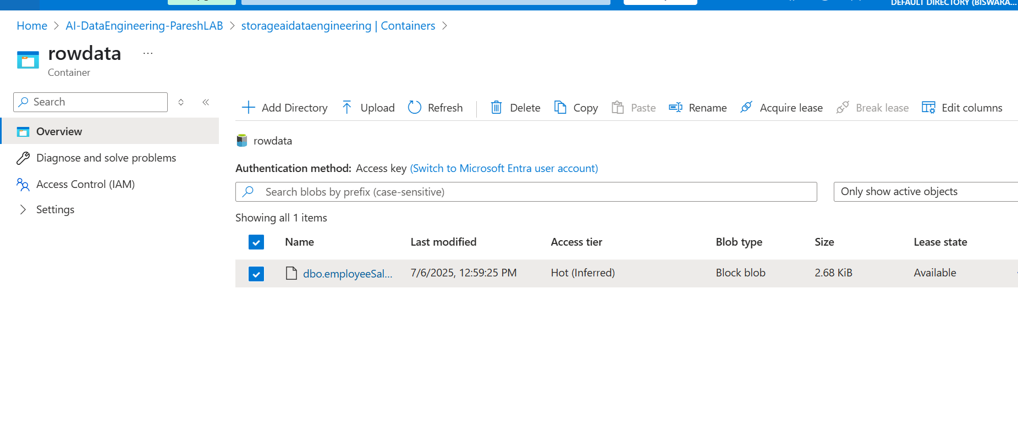

**✅ Validation 2: Schema Consistency  
Objective: Confirm that the column names, data types, and mappings in source and target tables are aligned.  
Example Line:**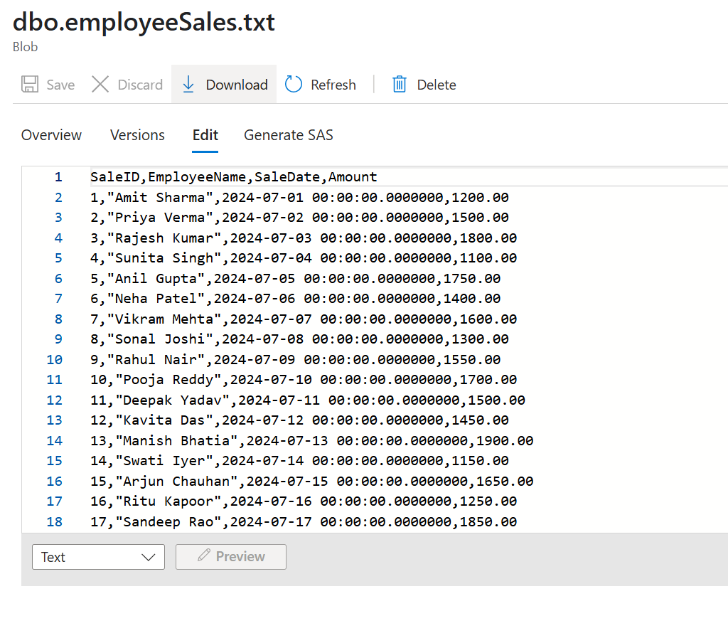

**✅ *Pipeline ran successfully. We performed Validation 1 — row count verification — and confirmed that the source and destination records match (e.g., 1,849 rows each). Schema and sample data were also verified.***